TECHNICAL PROJECT REPORT

# Title of Invention / Project:

Car Accident Detection Kit

# Team Members / Inventors:

|  |  |  |  |
| --- | --- | --- | --- |
| **S. No.** | **Name** | **Department** | **Designation** |
| 1. | Piyush | CSE(AI&ML) | Student |
| 2. | Pranay Reddy | CSE(AI&ML) | Student |
| 3. | Chitrang Juneja | CSE(AI&ML) | Student |
| 4. | Khushal Thakur | ECE | Mentor |
| 5. | Anshul Sharma | ECE | Mentor |
| 6. | Kiran Jot Singh | ECE | Mentor |
| 7. | Divneet Singh Kapoor | ECE | Mentor |

SECTION-1(IPR Related)

BRIEF ABSTRACT:

Road accidents take place in big cities almost every day. Sometimes, these accidents prove to be fatal. Two main factors responsible for road accidents are heavy traffic on roads and rash driving. No matter what the reason is, lives of people are lost because of such accidents.

According to fatal injury pattern identified by Trunkey in 1983,

more than half of the deaths were “immediate”, occurring within half an hour.  Approximately 30 percent of the total deaths occurred between half an hour and 3 hours post injury, with a peak at about an hour and a half after injury. These “early” deaths often resulted from major internal hemorrhage or severe blood loss. Trunkey argued that early medical intervention could save many of these patients.

It takes time before the medical intervention or aid arrives and takes the victim to the hospital. Usually the hospitals or police stations are informed by the public that where the accident took place and then only the medical aid arrives. It rarely or never happens that ambulance comes soon after the accident took place. And that too if accident takes place at a lonely place or at night then there is hardly any chance of quick aid to the victim.

So basically, the problem our project will be solving is to reduce number of lives lost in such accidents because of lack of medical intervention or the immediate help which victim is not able to receive on time.

**HOW ARE WE SOLVING THE PROBLEM?**

With Car Accident Detection Kit, an alerting message which contains accident’s time and location will be sent automatically by the particular device embedded in a vehicle to emergency and relief agencies. So, they can rush to the accident and help the victim in time. One will not have to wait for getting in sight of someone to witness the accident and then informing the relief agencies.

The accelerometer embedded in the device which will be set with a definite frequency will sense the vibrations and then with help of GPS location will be detected of the victim and will be sent to nearby relief agencies with the help of GSM.

**ADDITIONAL MODIFICATIONS THAT CAN CATER TO IMPROVED SOLUTION:**

* Drowsiness alert alarm can be installed in this device so that no such because of the driver falling asleep will take place.
* The device can be installed with small camera which can click pictures of the place where accident took place and can send the pictures of the area along with the location to relief agencies.
* Additional information like incident specific information, person specific information, and vehicle specific information can be provided alongside co-ordinates.

# Existing state-of-the-art and Drawbacks in existing state-of-the-art

|  |  |  |
| --- | --- | --- |
| **S. No.** | **Existing state of art** | **Drawbacks in existing state of art** |
| 1 | **Advanced automobile accident detection, data recordation and reporting system** GOOGLE PATENTS(US7348895B2) | * This will be fixed in particular locations which has sure chances that it can miss accidents if they take place anywhere out of reach of this device. * It is based on characteristic sounds and other cues for detection of location. |

Novel/Additional modifications that you can propose to improve upon drawbacks:

1. Instead of just setting up the device in Rural areas ,device can be pre installed in cars by the respective companies which will increase chances of providing information to the emergency services.So if accident takes place anywhere ,the emergency message will be sent with exact location of the accident spot.
2. It is based upon the amount of vibrations not upon the sounds and other cues as in sounds there are chances that accident may not take place but still because of hinderance in the surroundings emergency message may be sent to the relief agencies.

# Advantages:

* We can reduce number of deaths in such accidents.
* Installing drowsiness alarm will reduce the chances of such accidents.
* Sending the pictures of the location will make it easier for the relief services to identify the place.
* Additional information like incident specific information, person specific information, and vehicle specific information will help for the agencies to communicate easily with the victim’s family.
* It will make the work easier for policemen to investigate the scene and identify whose’s fault is there.

BLOCK DIAGRAM

MICROCONTROLLER

LCD

**SECTION-2(REAL PROJECT)**

**MATERIALS:**

|  |  |
| --- | --- |
| **MATERIALS** | **COST**  (in Rs.) |
| **Arduino Uno** | **380** |
| **GPS Module (SIM28ML)** | **1000** |
| **GSM Module (SIM900A)** | **1100** |
| **Accelerometer (ADXL335)** | **300** |
| **10K Potentiometer** | **50** |
| **16*2 LCD** | **250** |
| **Jumper Wires *30** | **90** |
| **Breadboard** | **50** |
| **12 V DC Power Supply** | **200** |
| **TOTAL** | **3420** |

**CIRCUIT DIAGRAM:**

**STEPS OF CIRCUIT COMPLETION:**

It was not an easy task to complete our project as it consisted of complexities like GPS, GSM, Accelerometer and never the less. We had to go through a hell lot of steps for our Circuit Completion:

1. Gathering all the material required for the circuit which included visiting electronics shop again and again as per the availability of different devices.

1. After learning about how to make connections, circuit formation started with connecting Arduino with different devices and breadboard.
2. Successful connection of LCD with Arduino, Potentiometer, GPS and Accelerometer.

1. **A circuit board

   Description automatically generated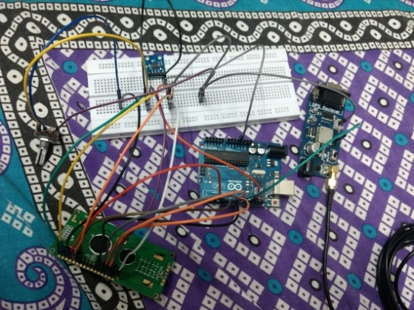**Further completion of circuit between GPS Module, Potentiometer and Arduino UNO.

1. Connection of Accelerometer with Arduino.

1. Finally connecting the GSM Module with Arduino UNO keeping in mind the placement of all jumper wires must be neat and clean.

1. **CODING**

**PROGRAM CODE:**

https://github.com/ChitrangJ/Car-Accident-Detection-Kit-/blob/master/ACCIDENT_DETECTION.ino